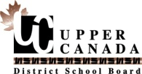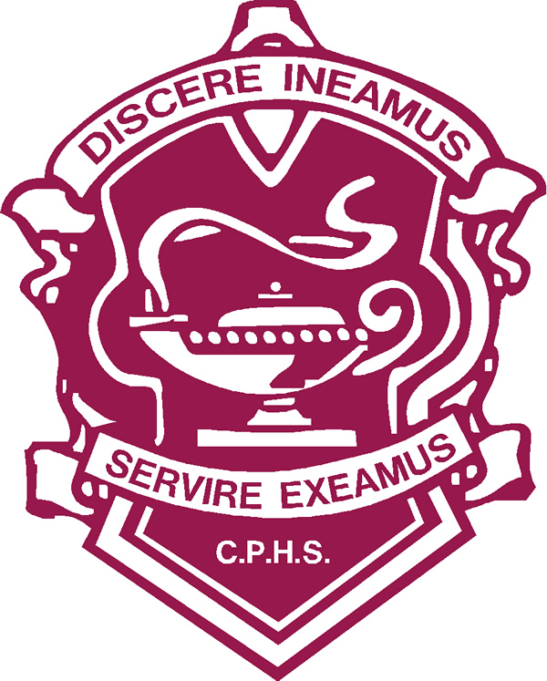 Carleton Place High School

English Course Outline

**Course Code:** EWC4U1 **Course Level:** University Preparation English

**Credit Value:** 1 **Room:**  218

**Textbook:** various sources **Pre-requisite:** ENG3U1

**Teachers:** Mike Moore **Program Leader:** Mrs. Heather Mortimer

**Course Description:**

This course emphasizes knowledge and skills related to the craft of writing. Students investigate models of effective writing and use a workshop approach to write, analyze and edit a variety of works; and make considered decisions for improving the quality of their writing. They also complete a creative or analytical independent study project and investigate opportunities for publication and for writing careers. The central theme of this course is Inspiration (what it is, how it works, where it comes from, how to use it.)

Course Critical Question: *To what degree can an effectively told story change the world?*

**Overall Course Expectations:**

**Investigative Writing**

By the end of this course, students will:

**Writing, Writers, and the Writing Life:** demonstrate an understanding of writing as an art, a craft, and a career as they explore the work of a variety of Canadian and international writers.

**Practicing Writing**

By the end of this course, students will demonstrate their skills in:

**1. Exploring Ideas, Forms, and Styles:** generate and experiment with ideas about writing content, forms, and styles;

**2. Drafting and Revising:** organize, draft, and revise their writing, employing forms and stylistic elements appropriate for their purpose and audience;

**3. Editing, Proofreading, and Publishing:** use editing, proofreading, and publishing skills and strategies to refine and polish their work;

**4. Collaborative Writing:** collaborate in the writing process with peers by generating ideas, responding to peers’ work, and assessing peers’ work in a workshop setting.

**Reflecting on Writing**

By the end of this course, students will:

**Metacognition:** identify their strengths as writers and areas where they could improve, and assess the growth and development of their own writing style.

|  |  |  |  |  |  |  |  |  |  |  |  |  |  |  |  |
| --- | --- | --- | --- | --- | --- | --- | --- | --- | --- | --- | --- | --- | --- | --- | --- |
| **Course Breakdown by Achievement Category:**   |  |  | | --- | --- | | Knowledge and Understanding | 25% | | Thinking | 25% | | Communication | 25% | | Application | 25% | | **Final Grade Determination:**   |  |  | | --- | --- | | Term Work (10% of which is the Oral Component) | 70% | | Finished Work Portfolio | 30% | | TOTAL | 100% | |

**Oral Communication/Interpersonal Component**

The Ministry of Education has asked for teachers to assess not only completed assignments, but focus upon personally seeing students working on their assignments, as well as seeing them attending to and participating in discussion of the subject matter during class time. Therefore, the work process and class interaction will be factored into calculation of final marks, rather than said marks reflecting solely the quality of finished written products. In keeping with this, 10% of the term work mark will be drawn from teachers’ observations regarding this (oral communication/interpersonal component) facet of student participation and work in the classroom.

Writing Portfolio

Given the curriculum’s emphasis upon process in evaluating student achievement, and because in particular it requires students to demonstrate and practice **editing** and **proofreading** (and to reflect upon their personal writing process), all written work will be submitted according to a two-step process, culminating in a writing portfolio which we do instead of midterm and final exams. (I will not award final marks for first drafts, as they do not clearly demonstrate editing and editing process.) To receive a mark, you will need to email a typed rough draft for my (and, occasionally, peer) feedback, and then, following directions given in that feedback, print the finished piece to demonstrate your editing process.

**Classroom Expectations:**

* Students may not skip any major assignment and simply move on to the next one. Completion of all major assignments is required in order to adequately demonstrate curricular expectations. Credits will be awarded only to students who complete all major assignments, demonstrating that their skills in those areas are up to provincial standard.
* Students are expected to show respect for everyone in the class: the teacher, other students, guests, and themselves. To that end, they are expected to attend regularly, be on time, have all their supplies, be prepared with completed homework and assignments, attend to (and not distract from) classroom discussions and demonstrate their best skills at all times. Students who persist in disrespectful behavior toward any person or group, present or otherwise, will need to deal with the office and will not be allowed back into the classroom until such time as they have demonstrated comprehension of their problematic behaviour, and expressed the intention to change it.
* Electronic devices will be stowed unless otherwise stipulated by your teacher for specific exercises. Surreptitious use of electronic devices will result in lunch detention/office referral.
* It is the student’s responsibility to deal with missed work, tests or assignments. Students are expected to catch up from any absences themselves, on their own time (not during class). Handouts and deadlines are posted on [www.mrmooreismyteacher.com](http://www.mrmooreismyteacher.com) Teachers are required to report on students’ skills in this area in ministry-mandated Learning Skills areas on provincial report cards.